Understanding Outreach, Screening, Assessment, and Referral Program Services to Address Opioid Use Disorder in Texas

Environmental Scan
Outreach, Screening, Assessment, and Referral (OSAR) programs address the needs of Texans at risk for developing or living with a substance use disorder by focusing on a continuum of services. During 2021 and 2022, the Texas Health and Human Services Commission (HHSC), the Addiction Research Institute at The University of Texas at Austin, and RTI International conducted a two-phase environmental scan of OSAR programs and partners in order to identify resources needed to enhance collaboration between OSAR programs, HHSC, and substance use disorder treatment providers.

Phase One Findings

General
- Provide training and technical assistance to support services using a person-centered approach.
- Provide training and technical assistance on the provision of services via telehealth.
- Increase staffing resources.
- Evaluate the long-term impact of OSAR program services.

Outreach
- Provide training on what constitutes outreach, including activities and locations.
- Develop curricula to train and educate local service providers to identify people at risk for opioid use disorder and directly refer to OSAR program providers.

Screening and Assessment
- Provide training and technical assistance to help OSAR program staff improve screening of priority populations.
- Streamline screening and assessment processes.

Referral
- Provide ongoing support for the use of telehealth.
- Determine how to connect clients to recovery support and other supportive services in addition to treatment.

Phase Two Findings

General
- Frequency of referrals was strongly associated with frequency of communication.
- Two-thirds (67 percent) of respondents reported they would prefer to communicate with their region’s OSAR program at least weekly.
- Only 36 percent of new employee respondents reported being very familiar with OSAR programs.

Communication
- Respondents indicated they frequently (54 percent) or infrequently (46 percent) communicated with their region’s OSAR program; however, the percentage varied by region.

Collaboration and Referral
- Over half (55 percent) of respondents reported their organization received client referrals from their region’s OSAR program.
- Over half (55 percent) of respondents reported they made referrals to their region’s OSAR program.
- Among respondents, 44 percent reported the most common way they received OSAR program referrals was via direct calls from the person calling after receiving information from the OSAR program.
- Over one-third (35 percent) of respondents reported the most common process of client referral was receiving a call from the OSAR program with client information and the provider being responsible for calling the client.
- Half (50 percent) of respondents reported they mostly provide the client with their region’s OSAR program information so that the client can call the OSAR program.
- Over one-third (34 percent) of respondents reported the most common process was to call the OSAR program, provide client information, and have the OSAR program call the client.
- Among respondents, 56 percent indicated their organization referred clients to their region’s OSAR program when their organization did not provide the recommended level of care.
  - About one-fifth (17 percent) of respondents indicated their organization referred clients to their region’s OSAR program when their organization was at capacity (e.g., did not have any available treatment spots).
  - Over half (52 percent) of respondents made referrals frequently.
  - One-fourth (25 percent) of respondents made referrals to their region’s OSAR program every day or nearly every day.
Figure 1. Most Common Methods of Referrals from OSAR Programs
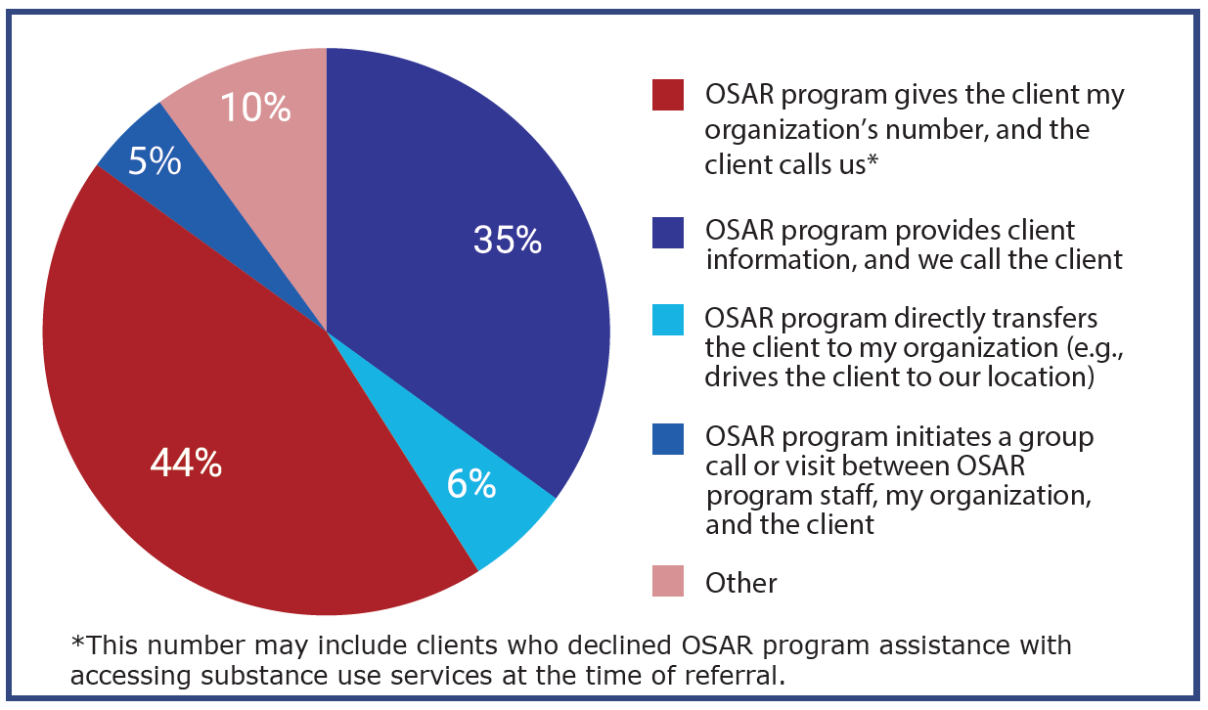

Texas Health and Human Services Commission Action Items

Training
- Provide training, refreshers, and technical assistance on telehealth and all OSAR program processes.

Funding
- Explore opportunities to increase OSAR program staff funding.

Communication
- Improve communication and relationships between OSAR programs and other providers.
  - Increase awareness among stakeholders.
  - Understand and work more closely with regions reporting less communication.
  - Identify and share best practices for referral processes across regions.
  - Increase collaboration through coalitions and outreach events.

System
- Assess feasibility of streamlining Clinical Management for Behavioral Health Services, consent, wait list, and other processes.

