Appendix XII, Create an Appeal Task in the HHSC Benefits Portal
Revision 18-0; Effective September 4, 2018
Program Support Unit (PSU) staff must take the following steps to create an appeal task in the Texas Health and Human Services (HHSC) Benefits portal in the Appeals/RFR tab; required fields are notated by an asterisk *.
- Click the Add New Appeal tab. Complete the required fields specific to the applicant, member, legally authorized representative (LAR) or authorized representative (AR) requesting an appeal in the top portion of the new appeal request.
  - Insert the date the appeal request was first received by HHSC in the Appeal Receipt Date;
  - Insert the date the appeal was requested. This is typically the same as the receipt date;
  - Case Number (same as the Texas Integrated Eligibility Redesign System (TIERS) number);
  - Appellant Name (typically the case name);
  - Method by which the appellant notified (enter the actual contact type such as by email, fax, in person, mail, or phone);
  - Hearing Telephone Contact # (enter the applicant, member, LAR or AR’s telephone number where they may be reached for questions regarding the appeal issue);
  - Appellant SSN;
  - DCN (Document Control Number of the imaged document), if available;
  - Appellant DOB (date of birth); and
  - Individual number (TIERS client number).
- Complete the Program area
  - Program—select the program being appealed.
    - The first four options (Community Care, Food Stamps, Medicaid and Temporary Assistance for Needy Families (TANF) are for Texas Works (TW); and
    - The last two options (Medicaid Eligibility and Medicare Cost Share) are intended for Medicaid for the Elderly and People with Disabilities (MEPD).
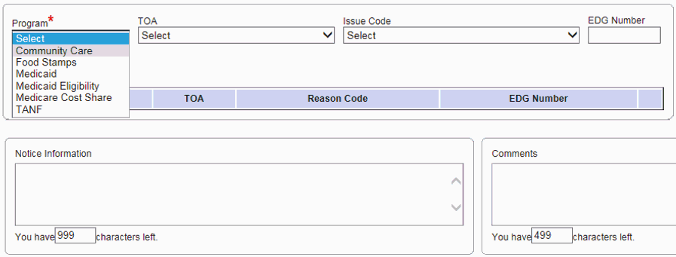
  - Click ‘ADD’ to confirm your selections; and
  - Comments—enter any pertinent information related to the appeal request.
    - Enter type of service (MDCP).
    - Enter whether continued benefits were requested or were not requested.
    - Enter “See email for witnesses,” which will be reflected on the email sent to Centralized Representation Unit (CRU) at the Texas Health and Human Services Commission (HHSC) Access and Eligibility Services (AES) Fair Hearings mailbox.
- Complete the Mailing Address area
  - Verify if the information is different from the address found in TIERS.
    - Str. #—enter the street number of the address;
    - Dir—direction (East, North, Northeast, Northwest, South, Southeast, Southwest, West);
    - Str. Name Rural Addr—enter the street name for the mailing address as it appears in the case record or where the applicant, member or authorized representative’s mail is sent;
    - Str. Type—enter the type of street name (Ex. Boulevard, Ave, Road, etc.);
    - Dwelling Type—enter the type of dwelling in the address. (Ex. Apartment, Room, Unit, etc.);
    - Address Line 2—enter if applicable;
    - County—county name where the applicant, member or authorized representative resides;
    - City—city name for the mailing address;
    - State—enter TX or Texas; and
    - Zipcode—enter the mailing address zipcode.
- Click ‘Save Record’ to complete the new appeal request.
- Review and ensure the appeal task was created, navigate to the HHSC Benefits portal Home tab, click on the Task List Manager (TLM) link.
- Then navigate to the Advanced Filter in TLM link and click on “Search by Case ID” to ensure the task was created and routed appropriately. If you are unable to locate the task by searching in the TLM Advanced Filter, you may search in PT Inquiry by entering the case number then scrolling to Active Tasks to view the appeal task created.
